Individual Weekly Report for Sam Baranov

Building a Unified Fitness Tracker System for Automated Progression Tracking and Planning

August 23, 2025

# Accomplishments

* Navigation shell refactor
* Consistent commenting and review of the entire codebase
* Portfolio final draft
* Held librarian meeting

# Weekly Activities

| Activity / Task / Work | Hours | Status |
| --- | --- | --- |
| Showcase 4 | 2.5 | Complete |
| Navigation shell refactor | 3 | Complete |
| Code base review and commenting | 8.5 | Complete |
| Colloquium attendance | 1 | Complete |
| Librarian meeting | 0.5 | Complete |
| Final portfolio | 4.5 | In progress |
| Presentation and poster peer reviews | 1 | Complete |
| Status report 9 | 1 | Complete |
| Placeholder screens | 1 | Complete |
| **Weekly Total** | **22** |  |
| Previous Weekly Cumulative Total (Carry Over) | 163.5 |
| **Current Cumulative Total** | **185.5** |

# Plans for Next Week

| Activity / Task / Work | Est Hours |
| --- | --- |
| Finish refactoring | 0-20 hrs |

# Response to Feedback

This week was low on feedback on the actual code, but the showcase and librarian meeting gave me a general sense that I am fine where I am at with my project. While my initial pitch of fitness app didn’t seem to resonate much with the librarian, explaining the actual feature set I am aiming for helped clarify the complexity of what I am aiming for.

Based on other peoples’ showcases of their projects, as well as what people described about their development process, I am continuing with the feature freeze until I am done cleaning up and refactoring the code base. I was worried that I was behind due to needing extensive refactoring/commenting on my code, but now it appears to be just a natural part of the development process for a project of this nature. And I have already started tackling this problem.

# Other Reflections

The two biggest achievements of this week have been in refactoring the worst part of my codebase, as well as review and commenting of said codebase.

I have refactored the navigation shell, which was previously a monolithic 1000+ lines code file that interlapped a lot of domain and UI logic. This was a holdover from before I properly understood BLoC state management earlier in the quarter. Now it is split into individual screens and reusable navigation components, maintaining a clear separation of concerns.

Second major achievement, and where majority of time has been spent, was going through the entire codebase and commenting for myself in the future, as was recommended during my code review. This took almost two entire days to complete, but the final result is that I have a very clear description of my entire system, along with specific points that need to be reviewed, extended, and improved upon. This will make future development far easier, especially in case I take an extended break from working on this project.

Commenting has also uncovered some more legacy components I had in my code which I also need to remove.

# Comments, Issues, Notes, Anything Else?

Filling this out, I am realizing that I am not actually at 200 hours for this quarter. But also there is only 9 status reports for this quarter, so 9*20 should be coming out to 180 hours. And I did end up getting past 20 hour average for each week.

# Evidence of Work

There hasn’t been much work that is easily showable, so I am including some snapshots of the worst parts, as well as the general state of the app as of right now.

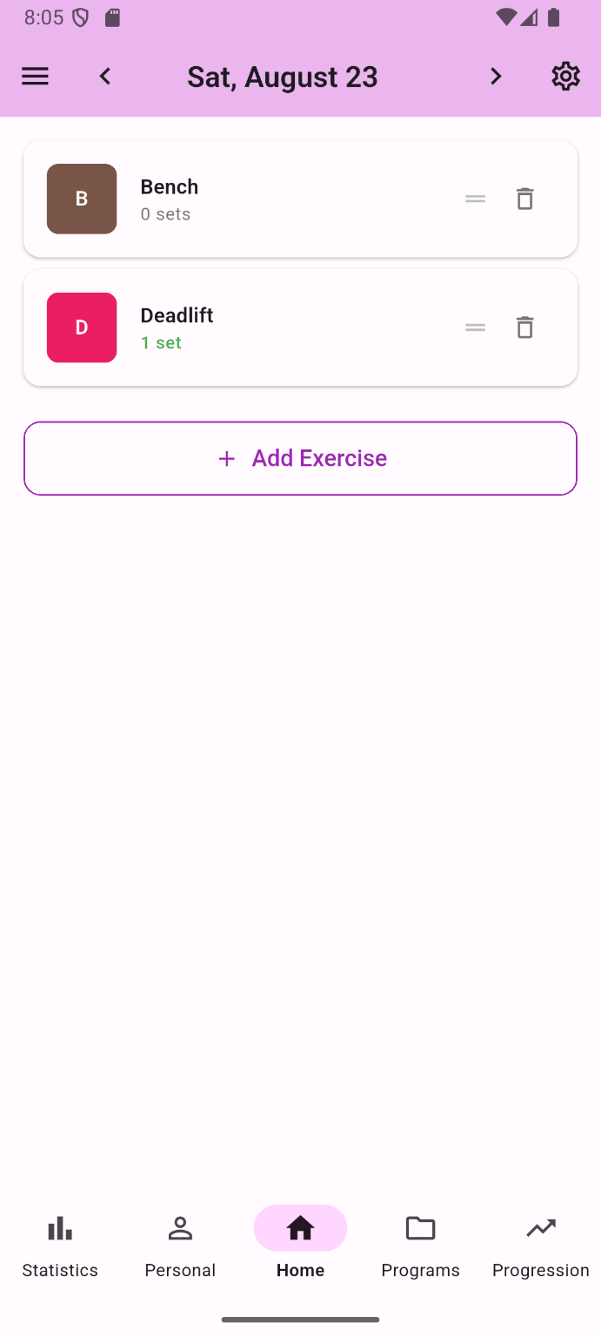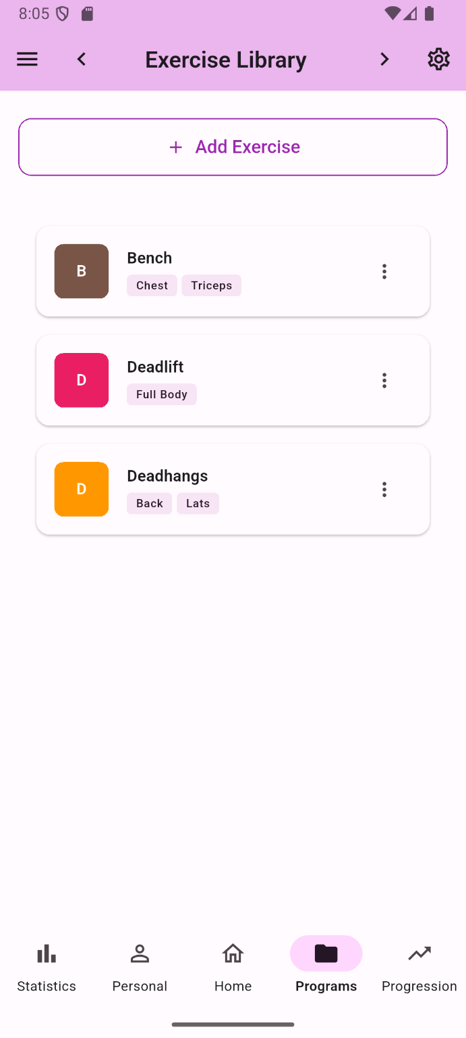

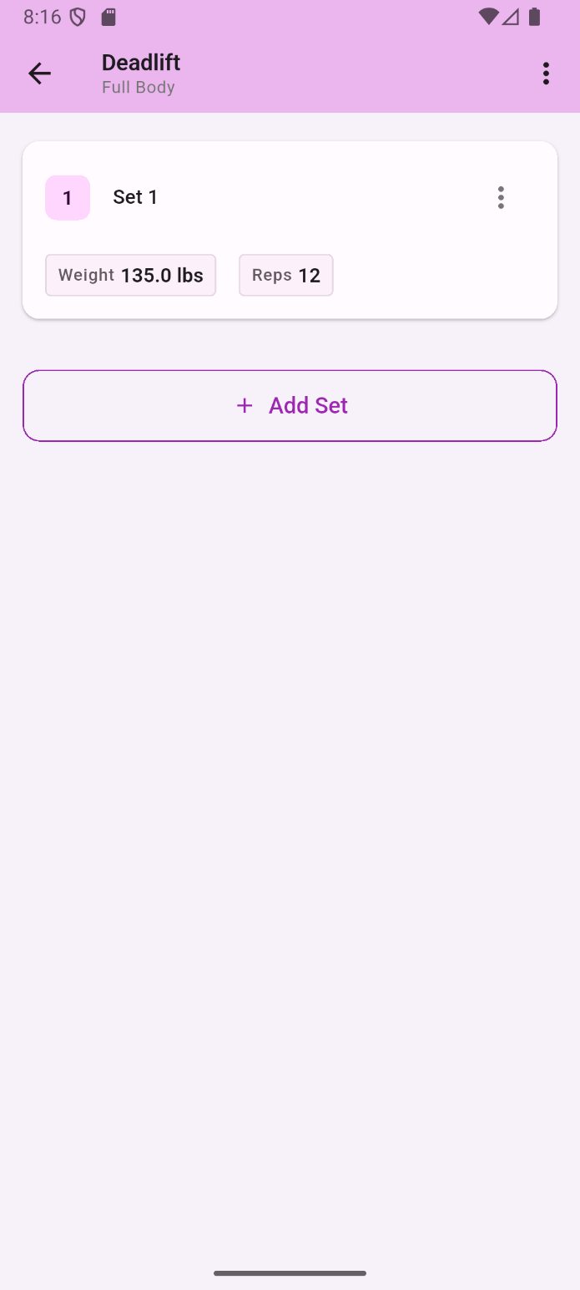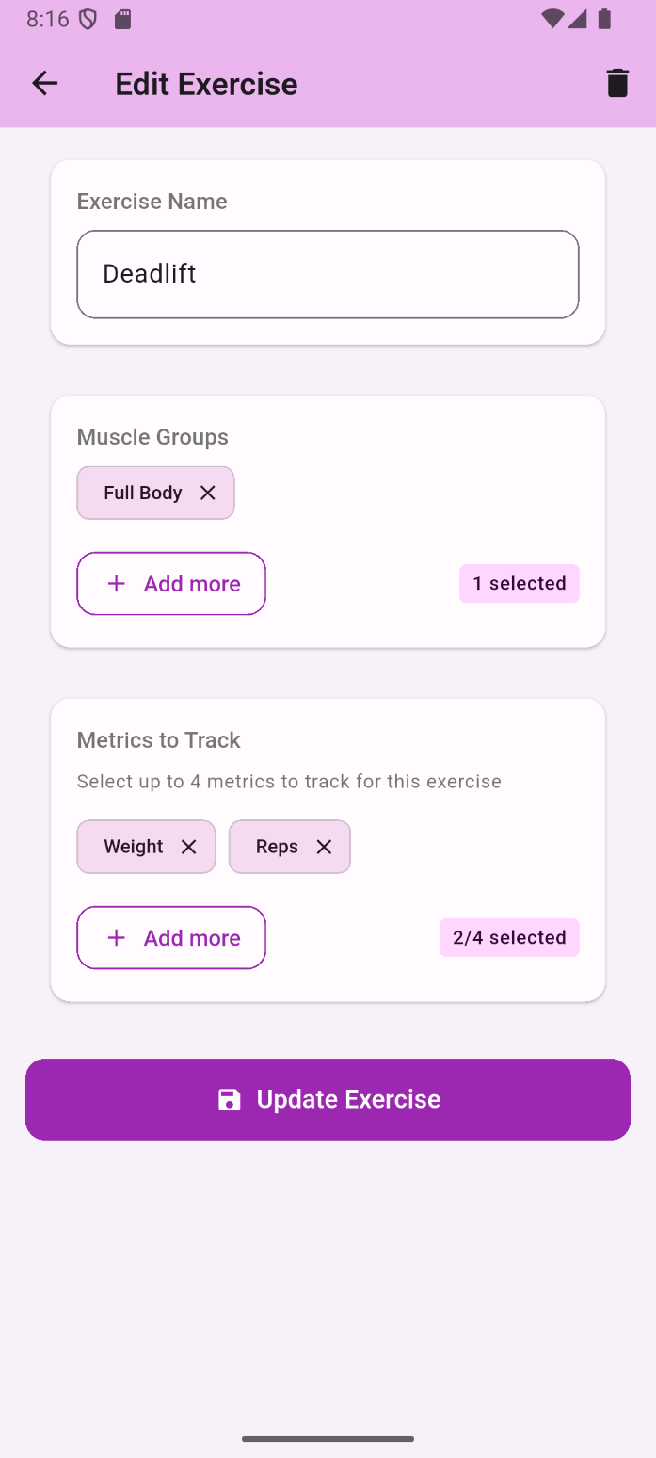

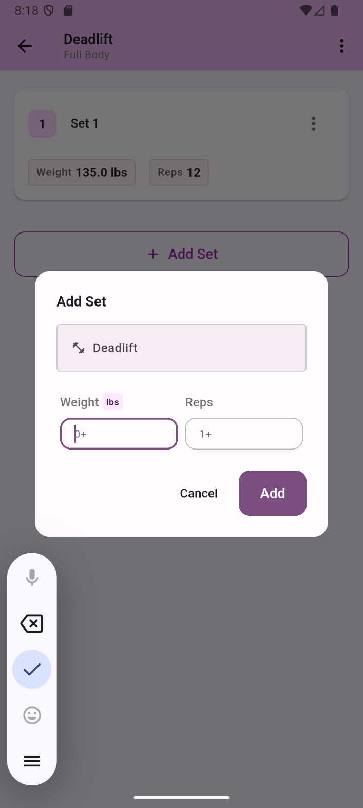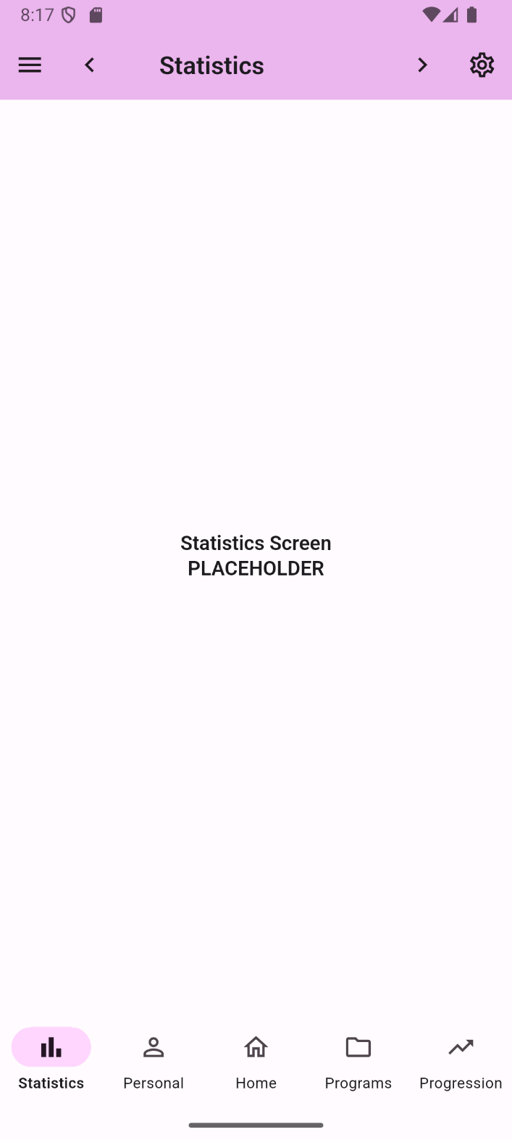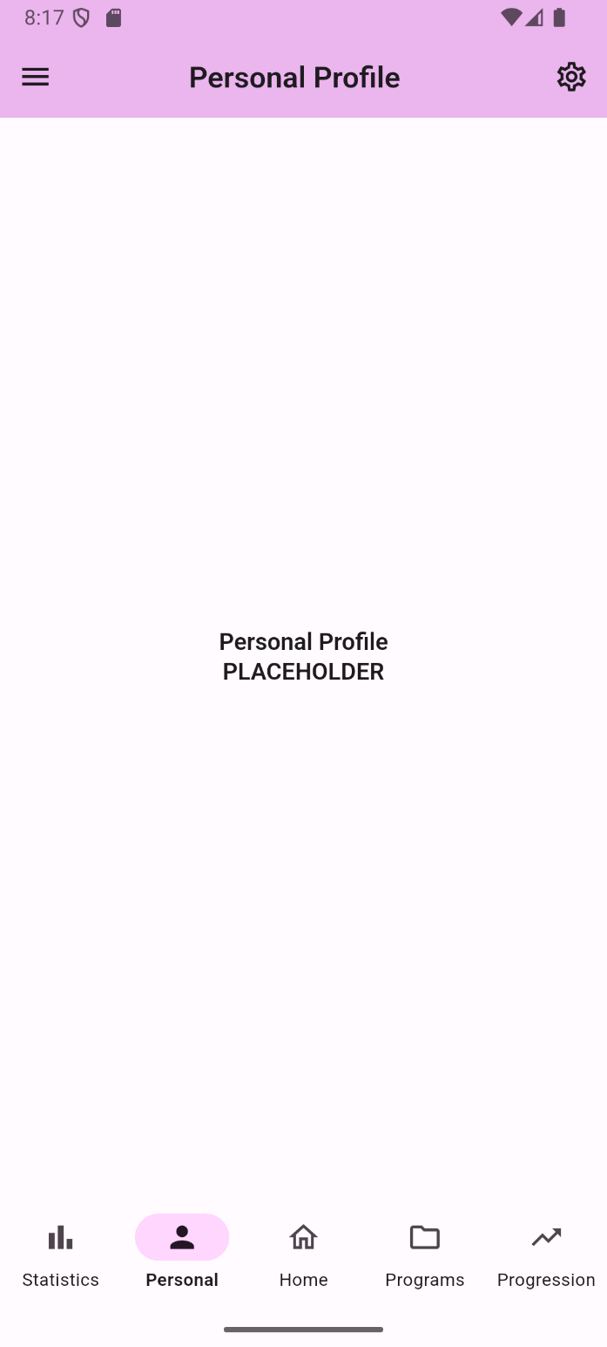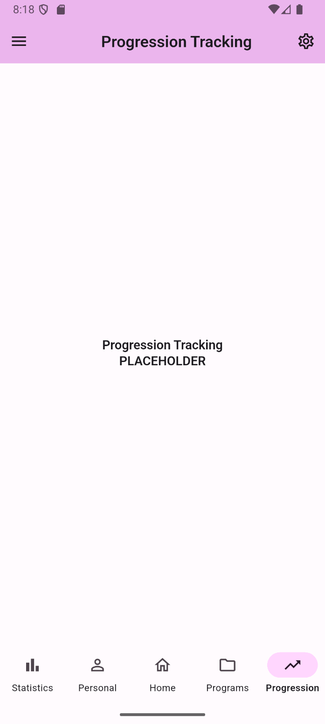

These are the core screens I have, as well as placeholders where future functionality is going to be implemented. The core flow of exercise creation, daily tracking, and set editing is complete, along with metric system. There is still a lot of visual polish, but it will come after refactoring is complete. As is, the app can already be used for fitness tracking in basic sense, and adding plan creation would fulfill practically all of common fitness app functionality.

Hard to show, but this is the reworked navigation shell file. It went from a 1000+ lines of code to a little under 200. This should make future development far, far easier. In later stages of this project, it became harder and harder to change existing systems, since it would almost inevitably create errors in the navigation shell. Now the information flow is far simpler, with navigation shell wiring together individual screens, widgets, and navigation, defined in self contained files.

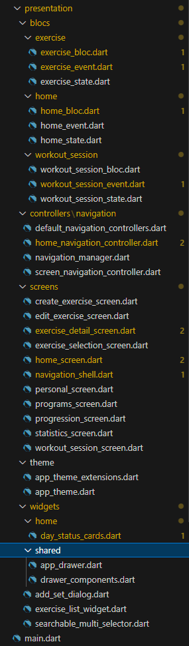

The 4 layers of the app as they are right now. All of the contents have now been reviewed and commented. I attempted to keep tone casual, as I am currently more concerned with conveying information to the future me, rather than pure organization.

Example of commenting. Regular comments concern general understanding of the system, while uppercase comments concern things that require actions, such as reviews, refactors, fixes, etc. Exercise detail screen is the next on the chopping block, as it is also currently holding too much responsibility in one place, and can be split up into more separate components.

# Interaction Report

Interaction Type: Librarian

Interaction Date: 08/21/2025

Attendees: Librarian

## Summary of Interaction

Because I didn’t realize how to sign up to the meeting earlier in the quarter, I only finally held it in the final week. The main outside research aspect of my project is surrounding the automated cycle planning and deloading systems for weightlifting. As such, this was the topic we discussed with the librarian. I introduced my project, along with distinct components that separate it from regular fitness apps. We discussed possibly topics that can be research, how to interact with research databases, and I got directions on how to get started with looking up relevant codewords.

## Action Items

* Start research on deloading biomechanics with concrete data
* Collect information from real world lifters on how they anticipate and structure their deloads

## Reflection on the Interaction

This meeting has worked as a kick-off to what I anticipate is going to be the hardest part of the entire project. While so far I have been primarily concerned with fields that I am either familiar with, such as general fitness information, or are easy to research on my own, such as UI development patterns in Flutter, automated deloading system represents the part where I have to model human behavior through code. And this requires researching said behavior, which requires concrete data on the topic. Thankfully, based on the librarian meeting, this appears like a well-documented topic in terms of scientific research, meaning that I now have a concrete direction for said research.